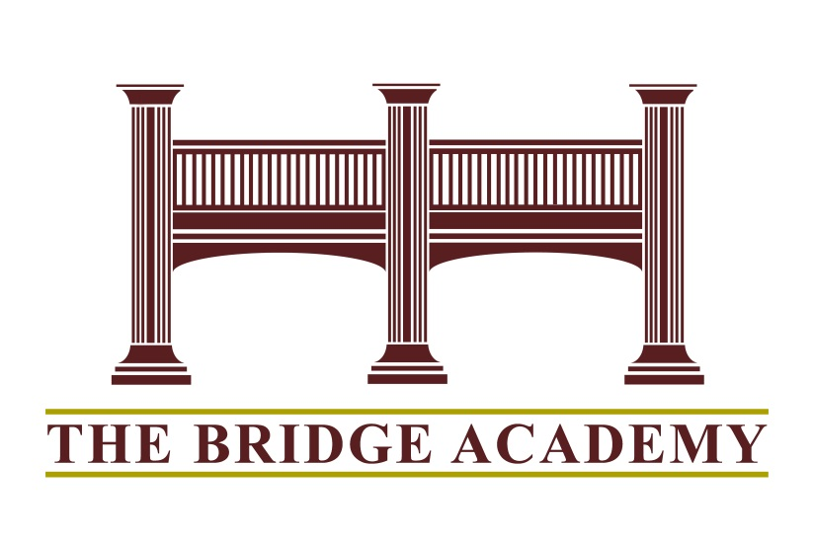

The Bridge Academy Reopening Plan 2020-21
The Bridge Academy Reopening Plan laid out in this document follows the expectations of the New Jersey Department of Education’s “Road To Recovery” Plan. We developed this plan to address challenges that may develop throughout the 2020-21 school year. Our goal is to be proactive in our preparation, planning, and response to continue to provide a positive, effective education for your child. Our plan was developed with parent/staff input, consultation with various health agencies, Advisory Coordinator Team and our school physician. We are planning for in person learning to begin in September.

While it is our goal to prepare a plan as best we can all plans are subject to change based on health issues and governing agencies. Please note that situations may arise where adjustments must be made quickly as such communication is key and families are asked to read email communication frequently or check our website, BANJ.org and use the drop down menu under Parent/Students, Student Forms to COVID 19 Information.

This plan includes General Health and Safety Guidelines, Staff Training, Building Management, Group Size and Student Groups, Transportation, Classroom Protocols, Student Flow, Entry, Exit, and Common Areas, Screening, PPE, and Response to Students and Staff Presenting Symptoms, Facilities Cleaning Practices, Contact Tracing, Recess/Physical Education, Field Trips, and Continuity of Learning.
We remain committed to providing your child with an environment that supports our students academically, socially-emotionally and physically.

August 25, 2020
General Health and Safety Guidelines
1. We have established and will maintain communication with local, county and state authorities to determine current mitigation levels in our community. School Nurse and Principal will stay in communication with local, county and state offices and use current information to inform decision making.
2. Designated COVID-19 Point of Contact –Our school nurse, Ms. Alexander, will be responsible for responding to COVID-19 concerns. Please contact Nurse Alexander at balexander@banj.org or call our school office.
Staff Training
1. Staff Training conducted in following areas:
• COVID-19 Signs and Symptoms
• Daily health screening for students and staff (daily use of forehead thermometer)
• Hand-washing practices
• Use of Personal Protective Equipment (PPE) – masks, gloves, face shields available for all staff
• Basic Emergency First Aid (First Responders Training)
• Awareness of distancing of 6 feet between individuals
• Face coverings when social distancing is not possible – masks will be worn inside at all times during program hours
• Cleaning protocols
Building Management
• Temperature screening at entry point for staff and at buses/cars for students
• Adequate ventilation
• Pictures and Signs delineating 6 feet for social distancing
• Pictures and Signs encouraging frequent handwashing, face covering
• Maintain adequate cleaning supply
• Routine daily cleaning, including common surfaces/shared objects
• Hand soap and hand sanitizer readily available
• Clean, disinfect, air-dry equipment after use
• Avoiding use of items not easily cleaned
• One person in a bathroom at a time
• Limit nonessential visitors
• Visitors are required to wear masks when entering the building and sign in
• Use of facilities outside of school hours will be limited and only with prior administrative approval
Group Size and Student Groups
• Limit group size to the extent possible (all groups are 10 or less), Math/Language Arts will continue to be four or less.
Lunch
• Our students are divided into numerous classrooms for eating lunch. They stay in consistent small groups and are spaced apart along with plexiglas screens. We do not have a cafeteria or serve meals.
Transportation
• Stagger drop off and pick up times (current practice)
Classroom Protocols
• Staff will wear masks and/or face shields whenever indoors and/or near students

• Staff will wipe down desks/tables in between each class (spray disinfectant and paper towels will be in every classroom)

• Hand sanitizer will be in every classroom and at entry door

•Each student will have a designated laptop w/ their name on it

• Students will wear masks indoors and in classes (we have disposable masks and/or cloth face masks we can give/designate for a child)

• Additional modifications will be in place in classrooms including using physical barriers (Plexiglas shields, clear plastic curtains) on desks/tables, turning desks to face the same direction, or having students sit on only one side of the table, spaced apart

• Use of shared objects will be limited and cleaned between uses

• When possible, ensure adequate supplies to minimize sharing of high touch materials to the extent possible.

• Increase circulation of outdoor air as much as possible, for example, by opening windows and doors.

• Teach outdoors where possible and when seasonally appropriate

Student Flow, Entry, Exit, and Common Areas

• School hallways will be designated one way as much as possible

• Students in Rooms 3, 6, 8, 9 and 10 will exit from the exterior doors.

Screening, PPE, and Response to Students and Staff Presenting Symptoms

• Temperature screening at entry point for staff and recorded daily
• Temperature screening at buses/cars for students – if a student presents with a fever they will be sent home and parents contacted
• Any student presenting with a fever or symptoms consistent with COVID during school hours will be in the isolation room until picked up by a parent/other designated adult
• Any staff member presenting with a fever or symptoms consistent with COVID during school hours will be sent home
* See CDC adopted guidelines appendix
Facilities Cleaning Practices

• Facilities will be maintained with daily cleaning using EPA approved disinfectant.

• Cleaning and disinfecting frequently touched surfaces will occur throughout the day and daily after school hours.

• If a member of the Bridge Academy Community tests positive the buildings will be cleaned using CDC guidelines.

Contact Tracing
• If a member of The Bridge Academy test results are positive for COVID-19, you will be notified by email that a “possible exposure has occurred”. You are advised to seek advice from your physician for next steps.
• If a student/staff member is identified through contact tracing defined as, anyone who was within six feet of the person for more than 10-15 minutes at least two days before the positive test if there were no symptoms, or two days before the first symptom appeared, you will receive additional notification.
• If a staff member is asked to quarantine they will also be asked to provide a list of any close contacts within the school community.
• All visitors to the building are asked to provide contact information
• Adhere to all applicable federal and state requirements regarding privacy of health and educational records
• Open communication system with our School Nurse that allow staff, students, and families to self-report symptoms and/or suspected exposure could assist us with prompt notification.
Recess/Physical Education
• There will be no contact sports or intergroup competitions
• Any outdoor activity will use minimal shared equipment. Equipment will be sanitized between use.
• When weather conditions prohibit outdoor Physical Education students will have health lessons
• Recess activities will be monitored for distance between students and numbers of students in any one area.
Field Trips
• There will be no off-site activities or field trips
Continuity of Learning - Remote
• Technology and Connectivity – Every student will have a school issued laptop to take home in the event we move to remote learning. Parents will be asked to sign a “Laptop Agreement” in advance of a student taking a laptop home
• Students will be expected to follow their regular class schedule and timeframe as they would have in person in school during remote instruction. Instructional times are 8am to 2:45pm. In some cases instructional times will be 8am to 1:15pm. Parents will be notified in the event of any schedule change.
• Students will be taught use of Google Classroom and Zoom in the beginning of the school year. Teachers will be required to use Google classroom to help students/parents with organization of assignments
• Teachers will continue to utilize a variety of methodology in instruction and as much direct instruction during remote learning to maximize student growth to the greatest extent possible.
• Student progress will be monitored during remote learning use progress markers designated in IEPs.
• Attendance will be monitored by the teacher and any student missing two classes in a row will be reported to the administration for additional follow up. Teachers should continue to communicate directly with the child’s parents via phone and/or email with any attendance concerns.
• IEP and other meetings will be held in coordination with the LEA either on site or virtual as needed.
• Related services will continue remotely as per IEP.
Administration Oversite
• Director of Education & Director of Business Administration is responsible for all planning, policy and funding. Board of Trustees approval as needed.

